Name : Soumya Dixit
PRN : 23070521151
Batch : B2 Sem : 5

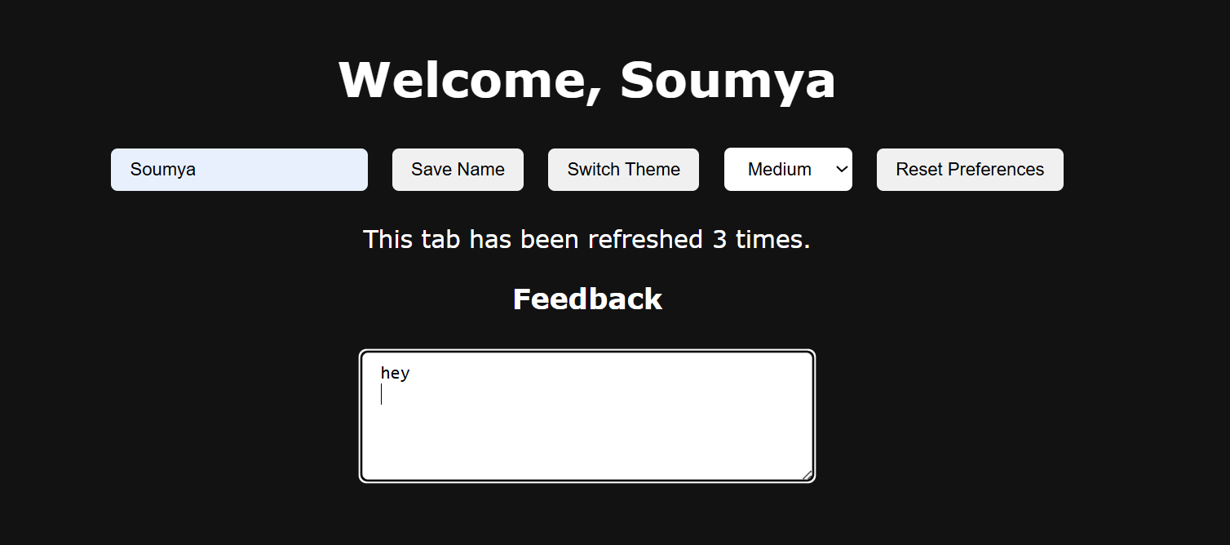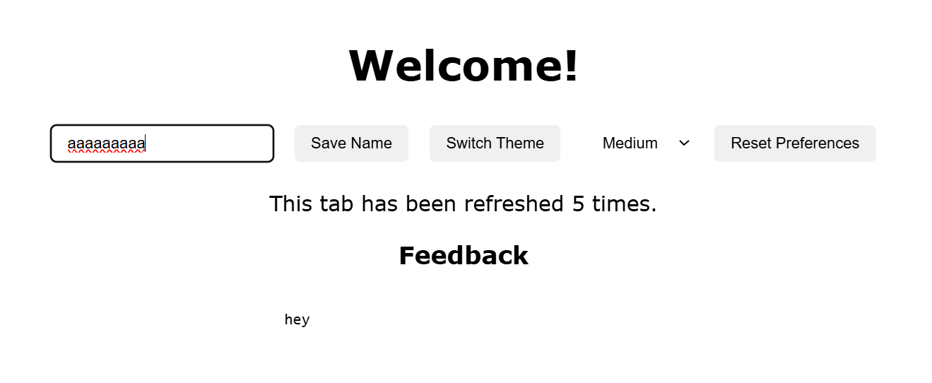
<!DOCTYPE html>
<html lang="en">
<head>
<meta charset="UTF-8">
<title>Personal Dashboard</title>
<style>
body {
font-family: Verdana, sans-serif;
transition: all 0.4s ease;
text-align: center;
padding: 20px;
}
.dark { background-color: #121212; color: white; }
.light { background-color: #ffffff; color: black; }

#controls button, select, input[type="text"], textarea {
margin: 6px;
padding: 8px 14px;
border: none;
border-radius: 5px;
cursor: pointer;
}

textarea { resize: vertical; min-height: 80px; }
</style>
</head>
<body>
<h1 id="welcomeText">Welcome!</h1>

<div id="controls">
<input type="text" id="userName" placeholder="Enter your name">
<button id="saveUser">Save Name</button>
<button id="themeBtn">Switch Theme</button>

<select id="fontChooser">
<option value="small">Small</option>
<option value="medium">Medium</option>
<option value="large">Large</option>
</select>

<button id="resetPrefs">Reset Preferences</button>
</div>

<p id="tabCounter"></p>

<h3>Feedback</h3>
<textarea id="feedback" rows="5" cols="40" placeholder="Your feedback..."></textarea>

<script>
const THEME_KEY = 'theme'; // Task 1: unified theme key (was ThemeMode/theme)
const FONT_KEY = 'fontsizePref'; // Task 2: consistent key (fixed capitalization)
const USER_KEY = 'username'; // Task 3: consistent key for username
const VISITS_KEY = 'visits'; // Task 4: session counter key
const FEEDBACK_KEY = 'feedbackText'; // Task 5: feedback key

const FONT_MAP = { // Task 2: added px mapping
small: '14px',
medium: '18px',
large: '22px'
};

const themeBtn = document.getElementById('themeBtn');
const fSelect = document.getElementById('fontChooser');
const saveUserBtn = document.getElementById('saveUser');
const inputUser = document.getElementById('userName');
const welcomeText = document.getElementById('welcomeText');
const tabCounter = document.getElementById('tabCounter');
const fb = document.getElementById('feedback');
const resetBtn = document.getElementById('resetPrefs');

// --- Task 1: Theme Fix ---
let themeNow = localStorage.getItem(THEME_KEY);
if (!themeNow) { themeNow = 'light'; localStorage.setItem(THEME_KEY, themeNow); } // default light theme
document.body.classList.remove('light', 'dark');
document.body.classList.add(themeNow); // fixed classList usage (was = t)

themeBtn.addEventListener('click', () => {
const newTheme = document.body.classList.contains('light') ? 'dark' : 'light';
document.body.classList.remove('light', 'dark');
document.body.classList.add(newTheme);
localStorage.setItem(THEME_KEY, newTheme); // fixed inconsistent key usage
});

// --- Task 2: Font Size ---
function applyFontSize(token) {
document.body.style.fontSize = FONT_MAP[token] || FONT_MAP['medium']; // added px and fallback
}

const storedFontToken = localStorage.getItem(FONT_KEY);
if (storedFontToken) { applyFontSize(storedFontToken); fSelect.value = storedFontToken; }
else { applyFontSize('medium'); fSelect.value = 'medium'; }

fSelect.addEventListener('change', () => {
const f = fSelect.value;
applyFontSize(f);
localStorage.setItem(FONT_KEY, f); // fixed capitalization mismatch (fontsizePref vs fontSizePref)
});

// --- Task 3: Username ---
function showUsername(name) {
welcomeText.innerText = name && name.trim() ? `Welcome, ${name}` : 'Welcome!'; // auto-show name
}

const savedUser = localStorage.getItem(USER_KEY);
if (savedUser) { showUsername(savedUser); inputUser.value = savedUser; } // fixed retrieval and display

saveUserBtn.addEventListener('click', () => {
const user = inputUser.value.trim();
if (user) { localStorage.setItem(USER_KEY, user); showUsername(user); } // fixed localStorage.name bug
else { localStorage.removeItem(USER_KEY); showUsername(null); }
});

// --- Task 4: Session Counter ---
let count = Number(sessionStorage.getItem(VISITS_KEY) || 0); // fixed type (string→number)
count = count + 1; // fixed count++ bug
sessionStorage.setItem(VISITS_KEY, String(count));
tabCounter.innerHTML = `This tab has been refreshed ${count} ${count === 1 ? 'time' : 'times'}.`; // fixed plural

// --- Task 5: Feedback ---
const savedFeedback = sessionStorage.getItem(FEEDBACK_KEY);
if (savedFeedback !== null) fb.value = savedFeedback; // fixed innerHTML → value
fb.addEventListener('input', () => { sessionStorage.setItem(FEEDBACK_KEY, fb.value); }); // added correct event
\
// --- Final Task: Reset Preferences ---
resetBtn.addEventListener('click', () => {
localStorage.clear(); // clears all persistent data
location.reload(); // reloads page
});
</script>
</body>
</html>

